How do I access MIDportal?

Follow the link to www.midportal.org.uk

Please ensure you update any bookmarks or shortcuts you may have saved to MID Update as you will no longer be able to access the website this way.

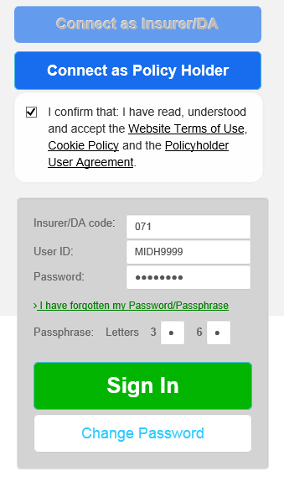
How do I log in to MIDportal?
From the start screen select ‘Connect as Policyholder’ and tick the declaration box to proceed.

The User ID, passphrase and password you use to access MID Update will allow you to log in to the new website. The Insurer/DA code is the same as your User ID prefix.

I have forgotten my User ID and log on details:
Please contact the MID Helpdesk by email on midhelp@nfumutual.co.uk or telephone 0800 197 1185

I have forgotten my password or passphrase:
Select the link ‘I have forgotten my Password/Passphrase’. You will need to provide your User ID to do this online.

If you have not logged in for more than 180 days, your access will be locked. Please contact the MID Helpdesk by email on midhelp@nfumutual.co.uk or telephone 0800 197 1185

What has changed?

The website enhancements include:

- New functionality to allow users to reset/change own passwords online;
- New site landing page and redesigned screens;
- A noticeboard feature to keep all users updated on the latest news and information on MID services changes;

How do I use the website?

Please refer to the appropriate quick reference guide below to give you guidance for using the new website:

Large Fleet Policyholder (link to Fleet QRG)
Motor trade Policyholder (link to MT QRG)

